New Feature of Triclops Software:

Red Frame and Progress Bar

Yixin Geng

1. **Introduction**

According to the stakeholders’ new requirement, we develop two new features for the software Triclops: red frame and progress bar.

The red frame is a feature which is shown below:

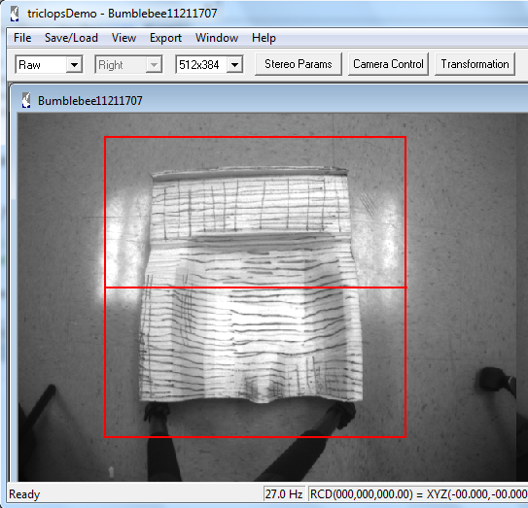

In the figure, the red frame means the region of interest (ROI), and the exporting file will only export the shape inside it. The red line in the middle is used to separate the ROI into two parts: back part and seat part. The upper part is the back part, and the lower part will be the seat part. Both parts will be exported into two 81×97 grid files separately.

The second feature is the progress bar. Progress bar is used to show users the progress of milling format file exporting since the progress always take about 5 or 6 minutes long, it seems that the computer gets stuck. It shows below:

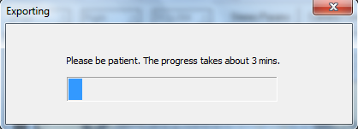

Before that the software will send a message telling user which part of the chair is exporting, the back or the seat.

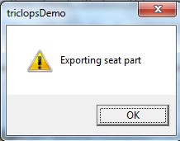

1. Specific Code Modification
2. Red frame:

The code used to implement red frame is in the class CPGRImageView(), including:

CPGRImageView::CPGRImageView()

Void CPGRImageView::OnDraw( CDC* pDC )

Void CPGRImageView::OnLButtonUp( UINT nFlags, CPoint point )

Void CPGRImageView::OnInitialUpdate()

Void CPGRImageView::OnLButtonDown(UINT nFlags, CPoint point)

The process is to initial a red pen object and use it to draw a rectangle. Then draw a red line in the middle through calcualting the two middle points’ positions.

1. Progress bar:

This feature is implemented mostly in the ProgressBar.cpp and its header file ProgressBar.h. The algorithm is to initialize the progress bar before calling the grid point calculating function and start to count during the calculation. When calcualtion of both parts finishes, the progress bar will be deleted automatically. The modified code includes:

ProgressBar.h

ProgressBar.cpp

void CPGRStereoDoc::OnFileExportHighResolution(float baseline, float smsurface)

CPointList *CPointList::getResolutionToPointList

(

CPointList *grid,

CPointList *realWorldPoint,

double startx,

double starty,

double endx,

double endy,

float smsurface,

int flag

)

1. Additional Feature

Because the software will export the milling format file into back and seat seperately, the software will ask the user to enter a saving name in the dialog box for once and save two files with extension _back.dat and _seat_dat. The following figures will demonstrate the process:

